SETTING UP VSCODE FOR ESP-IDF

Follow this tutorial to install ESP-IDF for VSCode: <https://github.com/espressif/vscode-esp-idf-extension/blob/master/docs/tutorial/install.md>. If ESP-IDF is already installed, select *Use existing setup*. Otherwise, select *Express*, which will install ESP-IDF and its tools.

Upon installation, Espressif logo will appear on the left side, from where you can access the extension.

You can configure your ESP-IDF extension, access examples, and create a new project from template by clicking **View > Command Palette**.

After creating a project, the bottom bar will look something like this:

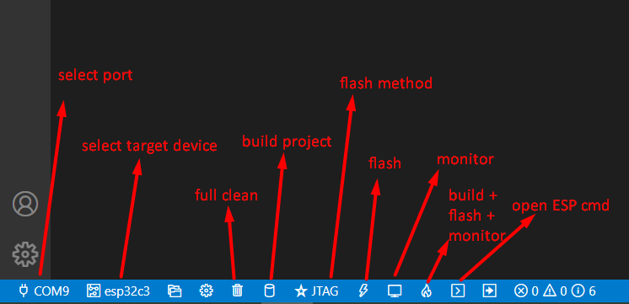

**Before building your project, you need to configure PORT and DEVICE TARGET.**

**Before flashing, you need to configure FLASH METHOD.**

You need to setup the port (of ESP-PROG) and Espressif device target by clicking on the bar. Available ports, devices and flash methods will appear on top.

After selecting the device target, the following will appear:

Where you select the first option if you're using ESP-PROG.

For **flash method**, if you are debugging using JTAG and ESP-PROG, select **JTAG.** Otherwise, if you've simply plugged your ESP32 into the PC with a USB cabel, select **UART.**

**Note**: if you haven't flashed this project yet, option „JTAG“ will not appear until you've clicked on „Flash device“ .

If you use the „Build + flash + monitor“, you will get an output, but there's no debug option.

For configuring the debugger, you have to add a new debug configuration, and select „ESP-IDF Debug: Launch“.

And that's it! The debugger is now ready to use!